Atomic Symbols and Isotopes

The nucleus contains ___________________ and _________________________.
Fill in the table:
 | Protons | Neutrons | Electrons
Location
Symbol
Charge
Approximate mass (amu)

All atoms of the same element have the same number of ________________________.
Isotopes are _____________________________________________________________________________.

_________ % of Lithium is Li-6, mass = 6.015122 amu
_________ % of Lithium is Li-7, mass = 7.016004 amu

The average mass of Li = (___________)(6.015122) + (_____________)(7.016004)
=

This number tells us_______________
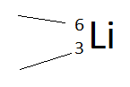

This number tells us ________________

Symbol | Mass | Protons | Neutrons | Electrons
⁶₃Li
⁷₃Li
⁶₃Li⁺
³³₁₆S²⁻
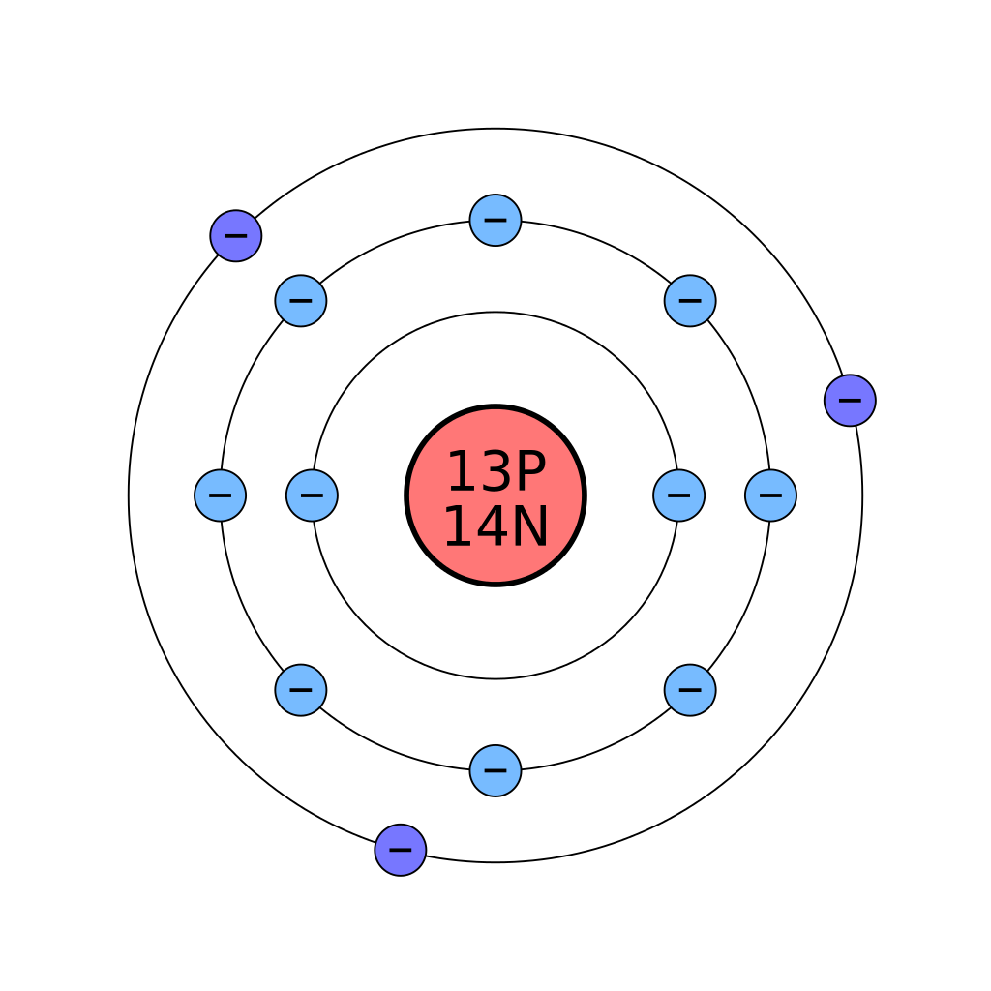
Protons =
Neutrons =
Mass =
Electrons =
Symbol is…..

